Overview  Country or Region: United States  Industry: Retail and Hospitality-Apparel Retailing  Customer Profile  The North Face provides a complete line of high-performance apparel, equipment, and footwear. The company has 14 retail stores and sponsors multiple expeditions each year with a team of 43 elite athletes.  Business Situation  As the company focused on opening small-format retail stores, it needed a way to show customers its full product line and to reinforce their connection to The North Face brand.  Solution  The North Face rolled out in-store digital kiosks that were built using the Microsoft® .NET Framework 3.0, Windows Vista™, Windows® Presentation Foundation, and Windows Communication Foundation.  Benefits  - Interactive, virtual product catalog  - Immersive experience with brand  - Self-service tool helps customers and salespeople |  |  | “Windows Presentation Foundation is the star of the kiosk. This robust technology enables us to create an immersive experience that we wouldn’t have been able to do otherwise.”  Darren David, Lead Software Engineer, Fluid
 |  |  | The North Face is a premier provider of outdoor gear. As it established new retail stores, the company sought an engaging way to present customers with its entire product inventory. The North Face also wanted to take advantage of thousands of hours of footage from technically challenging expeditions around the world to show customers how its products enable real adventures. The company partnered with Fluid, Inc., who used the Microsoft® .NET Framework 3.0 and Windows Vista™ to build a digital kiosk that supports 3-D graphics and integrated media. With the kiosk installed in all The North Face stores, the company has created an engaging, entertaining merchandising experience that allows customers to explore its full product line, integrates media that reinforces the core values of The North Face brand, and serves as a valuable resource for product information to customers and salespeople alike.
 |  |  | 

Situation
In 1966, two hiking enthusiasts set up a small retail store in San Francisco, California, and began selling high-performance climbing and backpacking gear. That store soon became The North Face. Today, 40 years later, The North Face has become a leading provider of the most technically advanced outdoor apparel, equipment, and footwear on the market. In addition to designing and selling premier outerwear, the company also sponsors a team of 43 elite athletes and conducts up to 10 annual expeditions. Examples include the first woman to ski from the Mount Everest summit and a runner’s successful completion of 50 marathons in 50 days in 50 states. These expeditions are filmed, photographed, and chronicled by journalists and provide thousands of hours of content showing athletes in extreme conditions and pushing the boundaries of their sport, all enabled by products from The North Face.
Fast Facts
Number of Developers | 4
Development Time | 9 months
Key Technologies | - Windows Presentation Foundation  - Windows Communication Foundation
Programming Language | Microsoft Visual C#
Number of Products Accessed | 500–800

The North Face had grown to rely heavily on third-party dealers to sell its product line. But the company also maintained several stand-alone retail stores—all of which were doing extremely well. The North Face began to open additional stores in select, high-volume markets; however, these stores did not have the square footage necessary to display the company’s extensive product line. The North Face needed to find the most engaging and effective way to expose customers to its entire product catalog—bringing these products to life.

“We have thousands of hours of footage of athletes using our products on expeditions, which we knew could be a strong asset in our in-store marketing and retailing efforts. But we were challenged to bring this content to life for consumers so they could really feel what our athletes were experiencing,” explains Joe Flannery, Vice President of Marketing for The North Face. “At the same time, we were opening more of these compact retail stores with limited inventory and wanted to create an engaging way to introduce customers to our entire product line.”

Flannery continues, “We saw an opportunity to address both challenges by creating a digital kiosk within our stores that would help our customers understand who we are, who our athletes are, what our athletes are doing—and at the same time really see our products in action in an interactive, entertaining format.”

Solution
The digital kiosk had several lofty goals. The North Face wanted to support 3-D product views and integrated media using content from expeditions and athlete interviews. While the company wanted to present customers with an experience that was unique from its Web site, it also wanted to coordinate content updates, automatically, between the kiosk and the company Web site. For example, when a jacket is discontinued, The North Face wanted to ensure that information was reflected on both the Web site and the in-store kiosks so customers were always getting consistent, up-to-date information.

Choosing a Partner and Technology
To help accommodate these needs, The North Face turned to Fluid, Inc., a San Francisco-based company that delivers innovative interactive merchandising products and solutions to online retailers. The North Face had used Fluid to redesign and update its Web site and wanted to leverage this strong working relationship. Fluid had been working closely with Microsoft to investigate its up-and-coming product offerings: the Microsoft® .NET Framework 3.0 and Windows Vista™. Given the cutting-edge capabilities of Microsoft technology and the technically advanced needs of The North Face, Fluid saw a perfect match.

“We chose Windows Vista and the .NET Framework for The North Face project because it’s the only solution that would enable us to create a truly innovative kiosk that transforms the shopping experience for customers,” explains Andrew Sirotnik, Chief Experience Officer for Fluid. “Using Microsoft technology, we could support 3-D product views and integrated media to deliver a super-engaging interface and television-like content. And we could accomplish these feats, which had never been done before, efficiently and cost-effectively.”

Developing the Kiosk
When Fluid first initiated The North Face kiosk project, the four developers working on the project had little to no experience using Microsoft technology. Despite this, the developers were able to gain experience as the project progressed and surprised many people by creating the first prototype application in a mere six weeks.
“Using Microsoft technology, we could support 3-D product views and integrated media to deliver a super-engaging interface and television-like content … efficiently and cost-effectively.”
Andrew Sirotnik, Chief Experience Officer, Fluid

“Before this project, we were not a Microsoft shop. We did not have any experience writing C#,” says Darren David, Lead Software Engineer for Fluid. “But within six weeks, we had a working, 3-D prototype of the application—it was jaw-dropping to everyone how quickly we were able to do everything.”

Overall development for The North Face kiosk was completed during a nine-month period and was divided into two separate phases. The first phase involved building the user interface and the kiosk application, during which developers relied heavily on Windows® Presentation Foundation. This .NET Framework technology provides classes and a unified programming model for building next-generation, smart client applications that combine the user interface, documents, and media to create compelling user experiences. Due to the richness of Windows Presentation Foundation, the kiosk supports playback of up to five simultaneous video streams composited on top of a background of panning, scaling, and cross-fading full-screen images.

“Windows Presentation Foundation is the star of the kiosk. This robust technology enables us to create an immersive experience that we wouldn’t have been able to do otherwise,” says David. “On a single page, customers can view and rotate products and watch expedition videos and athlete interviews. Overall, Windows Presentation Foundation supports an experience that is engaging, integrated, responsive, and interactive—exactly what The North Face had envisioned.” (See Figure 1).

The second phase of the project focused on creating the content updating system. This system will leverage the company’s existing asset management system and enable The North Face to make a product change in one place and simultaneously update the Web site and kiosk. Updates are expected to occur in the fall and spring for the entire product catalog (500 to 800 products), and the files may range in size from four kilobytes to several hundred megabytes.

“If Windows Presentation Foundation is the star of the kiosk, Windows Communication Foundation is the supporting cast,” explains David. “The content update system is a well-timed concert of four applications that enable updates to happen, and we use Windows Communication Foundation to ensure the applications can work together and communicate smoothly. Microsoft Message Queuing 4.0 also allows applications to communicate and provides us with centralized control, so if one application fails, the entire update system is not compromised. Finally, ClickOnce deployment guarantees that the applications managing the entire process are always up-to-date with the latest patches and security updates.”

To support the high-performing, graphic, and media-rich application, The North Face kiosk is installed on computers running Windows Vista. In addition, to support touch-screen capabilities, the kiosk uses technology from Elo TouchSystems, a global leader in developing, manufacturing, and marketing touch technology.
Figure 1. View products, videos, and interviews all on one page.
Benefits
The North Face kiosk, which is available in 14 stores across the United States, is helping the company transform the customer shopping experience. Despite limited shop space, customers can view and interact with the entire product catalog and gain a strong sense of the various products, even when those products are unavailable in the store. In addition, by connecting customers to exhilarating content from expeditions, The North Face further solidifies its position as a company committed to pushing the limits of design so customers can push their personal and physical limits outdoors. Finally, the multifaceted, self-service tool provides something for everyone—customers and salespeople alike.
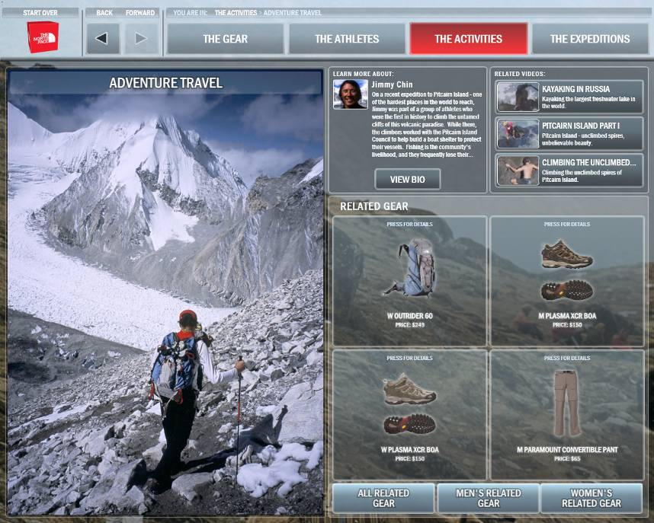

“Shopping is about social entertainment,” explains Sirotnik. “With The North Face kiosk, we’ve created a new type of customer experience, one that delivers an exciting, entertaining shopping experience and also immerses the customer in The North Face brand.”

Interactive, Virtual Product Catalog
The North Face never intended to open large retail spaces that could accommodate its entire product inventory. With The North Face kiosk, it has the next best thing.

Using the touch-screen kiosk, customers can search for items based on a specific activity or clothing item. They can zoom into the picture to see fine product details, rotate the picture to get a 3-D view, and even view the product in multiple color schemes. At the same time, they can view footage of an expedition during which the athlete used the same gear, giving the customer a true sense of how the gear stands up to the elements. When customers decide to purchase a product that is not available in the store, they can print out a “hang tag” with information about the product and then order the item from various online dealers or ask the salesperson to order it directly from The North Face.

“The North Face kiosk allows us to showcase the full breadth of our store inventory in a very compelling way—even when stores don’t have the space to carry the product,” explains Flannery . “Ultimately, this will help us increase sales and deliver on the full potential of the new store formats.”
“The North Face kiosk allows us to showcase the full breadth of our store inventory in a very compelling way—even when stores don’t have the space to carry the product.”
Joe Flannery, Vice President of Marketing,
The North Face

Immersive Experience with Brand
Athletes and expeditions—all documented in thousands of hours of content—define the core essence of The North Face. Despite its accelerated growth pattern, the company did not want to lose focus of its core customers. By connecting customers to this content through The North Face kiosk, the company demonstrates its commitment to outdoor adventures and reinforces the brand through a highly entertaining, engaging medium.

“Using Windows Vista and the .NET Framework, we had the technology we needed to expose customers to very rich content in the most compelling way,” explains Kent Deverell, Principal for Fluid. “This content is displayed in a richly integrated environment that captures people’s attention and helps The North Face communicate what the brand is all about.”

Self-Service Tool Helps Customers and Salespeople
“There are different types of customers out there, and not everyone wants to talk to a salesperson—they want to research, view, and compare every technical specification on a product,” Flannery explains. “The North Face kiosk provides an opportunity for people to help themselves, either when there’s no available sales staff or if that’s just the way they prefer to shop.”

Customers simply scan the product’s bar code to pull up technical specifications, access the entire color palette, and view relevant video content. Those who don’t know exactly what they’re looking for but don’t want sales assistance can browse and compare products on the kiosk.

The North Face kiosk is also turning out to be a true asset for salespeople. It is a challenge for sales personnel to become well-versed in all the products in the extensive The North Face catalog. So, if a customer has a specific question about Hyvent technology—a waterproof, breathable membrane used in outerwear—the salesperson can either explain it or pull up the relevant information on the kiosk and use expedition footage to demonstrate the strength and power of the technology. Consequently, the kiosk is proving to be a valuable training tool as well.

Moving Forward
Looking to the future, The North Face is confident that the kiosk will provide customers with a consistently engaging and new experience each time they visit a store. In addition, the company anticipates using the infrastructure that is already in place for the kiosks to control in-store signage. Soon, The North Face will use a content presentation system, built using Windows Presentation Foundation, to publish videos, slide shows, and photos to individual stores. Utilizing this system, The North Face could take footage from an expedition like Everest, customize it with specific text messaging, and publish it to the large-format plasma screen strategically placed in its store in the SoHo neighborhood of Manhattan.

Deverell explains, “Using Windows Vista, the system will combine footage and messaging in a very professional manner. Something that once would require a full-time video editor soon will be completed by resources at The North Face.”

The North Face is thrilled with the results the kiosk has already delivered and the possibility of where it might go. Flannery adds, “By using powerful technology such as Windows Vista and the .NET Framework, we’ve delivered on our vision: leveraging our video assets to deliver dynamic marketing messages that expand and enrich the customer experience in our compact format stores. We’re excited about what we’ve accomplished and look forward to discovering how Microsoft technology can continue to help us push the boundaries.”

Windows Vista
For More Information
For more information about Microsoft products and services, call the Microsoft Sales Information Center at (800) 426-9400. In Canada, call the Microsoft Canada Information Centre at (877) 568-2495. Customers who are deaf or hard-of-hearing can reach Microsoft text telephone (TTY/TDD) services at (800) 892-5234 in the United States or (905) 568-9641 in Canada. Outside the 50 United States and Canada, please contact your local Microsoft subsidiary. To access information using the World Wide Web, go to:
www.microsoft.com

For more information about The North Face products and services, call (866) 715-3223 or visit the Web site at:
www.thenorthface.com

For more information about Fluid products and services, call (415) 369-3200 or visit the Web site at:
www.fluid.com

© 2007 Microsoft Corporation. This case study is for informational purposes only. MICROSOFT MAKES NO WARRANTIES, EXPRESS OR IMPLIED, IN THIS SUMMARY.

Document published March 2007

Software and Services  - Windows Vista  - Technologies  - Microsoft .NET Framework 3.0  - Windows Communication Foundation  - Windows Presentation Foundation | Partners  - Fluid, Inc.

Windows Vista can help your organization use information technology to gain a competitive advantage in today’s new world of work. Your people will be able to find and use information more effectively. You will be able to support your mobile work force with better access to shared data and collaboration tools. And your IT staff will have better tools and technologies to enhance corporate IT security, data protection, and more efficient deployment and management.

For more information about Windows Vista, go to:
www.microsoft.com/windowsvista

